New Hanover High dedicates monument to WWII heroes
Story by: Pressley.Baird@StarNewsOnline.com
May 24, 2013

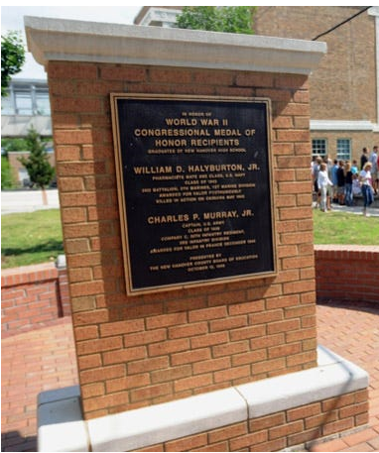
NHHS Medal of Honor Memorial Garden, May 24, 2013
The crowd in front of New Hanover High School was equal parts past and present.
There were New Hanover alumni from the 1940s and 1950s. They are veterans of World War II and the Korean War and the Vietnam War, representing a school that sent hundreds of its students to fight.
There were also current New Hanover students, seniors who will be alumni in a few weeks. Many of them are veterans of the school's ROTC program, rising through its ranks during their high school careers.
They were all there to dedicate the school's Medal of Honor Memorial Garden, a brick monument surrounded by greenery, and to honor two alumni who received Medals of Honor for their service during World War II: Col. Charles Murray, who graduated in 1938, and Petty Officer Billy Halyburton, a member of the class of 1943. Just three days before Memorial Day, it was fitting to remember the hundreds of other servicemen and women who were, as World War II Wilmington Home Front Heritage Coalition chairman Wilbur Jones put it, "a microcosm of combat by Americans anywhere, anytime in World War II."
The audience at Friday's ceremony saw the big picture of New Hanover's place in World War II. It heard about Murray and Halyburton, the two men who make New Hanover supposedly the only high school in the country with two Medal of Honor recipients. It also heard about New Hanover's ROTC program, the oldest in North Carolina with its 1937 creation. And it heard about the efforts being made in Congress to name Wilmington as the first recognized All-American World War II City.
But the crowd also heard the smaller details of the school in wartime. School board Chairman Don Hayes remembered being a member of the ROTC's Cape Fear Rifles, a precision drill team. Jones talked about students listening to President Franklin Roosevelt's speech after Pearl Harbor was bombed. And James Lee, a member of New Hanover's 1944 class and a retired Army lieutenant general, spoke about the patriotism at the school in those days – something, he said, that the students were also showing Friday.
"(New Hanover) is producing citizens of character, good behavior and patriotism," Lee said. "Thank you for being who you are, young people."
Hearing that was meaningful to Cadet Lieutenant Colonel Alison Oehling, a junior, and Cadet Captain Ben Meyer, a sophomore. Decked out in full ROTC regalia, the two said they felt honored to see the veterans who came before them as New Hanover students.
Oehling and Meyer admired the veterans' service to the country, they said, but they also admired their connection to New Hanover. As Meyer put it: "It's pretty cool to walk the same hallways as they did."

